**AERO-MODELLING**

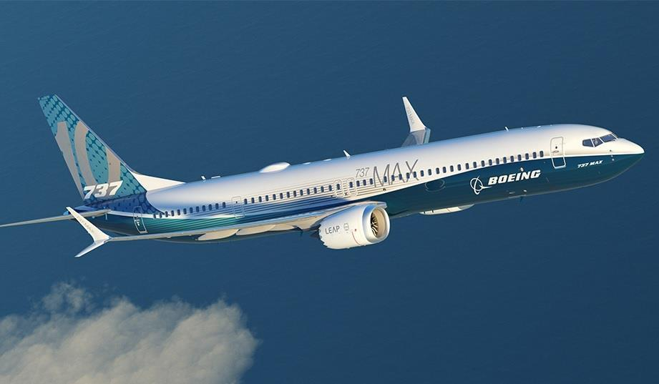

PROJECT BY:

**GAUTAM KUMAR**

**(20203059)**

***MODELLING OF AN AEROPLANE***

**PROJECT OUTLINE**

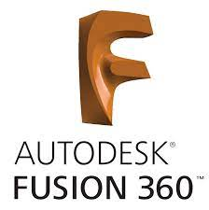The aeroplane model design is inspired from Boeing 737 aircraft and it is designed using **Autodesk Fusion 360** which is a cloud based design tool **.**The main purpose of it is to create a more efficient design for aircraft.

Model link: <https://a360.co/378w265>

**OBJECTIVE**

The objective of this project is to create a 3-D model of boeing 737 aircraft.

***INTRODUCTION***

An **airplane** or **aeroplane** is a [fixed-wing aircraft](https://en.wikipedia.org/wiki/Fixed-wing_aircraft) that is propelled forward by [thrust](https://en.wikipedia.org/wiki/Thrust) from a [jet engine](https://en.wikipedia.org/wiki/Jet_engine), [propeller](https://en.wikipedia.org/wiki/Propeller_(aircraft)), or [rocket engine](https://en.wikipedia.org/wiki/Rocket_engine). The broad spectrum of uses for airplanes includes [recreation](https://en.wikipedia.org/wiki/Recreation), [transportation](https://en.wikipedia.org/wiki/Air_transportation) of goods and people, [military](https://en.wikipedia.org/wiki/Military_aviation), and research. The **aircraft design process** is a loosely defined method used to balance many competing and demanding requirements to produce an aircraft that is strong, lightweight, economical and can carry an adequate payload while being sufficiently reliable to safely fly for the design life of the aircraft. Similar to, but more exacting than, the usual [engineering design process](https://en.wikipedia.org/wiki/Engineering_design_process), the technique is highly iterative, involving high level configuration trade off, a mixture of analysis and testing and the detailed examination of the adequacy of every part of the structure. For some types of aircraft, the design process is regulated by [national airworthiness authorities](https://en.wikipedia.org/wiki/National_aviation_authority).

**PURPOSE OF DESIGNING and MODELLING**

The design process starts with the aircraft's intended purpose. Commercial airliners are designed for carrying a passenger or cargo payload, long range and greater fuel efficiency whereas fighter jets are designed to perform high speed manoeuvres and provide close support to ground troops. Some aircraft have specific missions, for instance, [amphibious airplanes](https://en.wikipedia.org/wiki/Amphibious_aircraft) have a unique design that allows them to operate from both land and water, some fighters, like the [Harrier Jump Jet](https://en.wikipedia.org/wiki/Harrier_Jump_Jet), have [VTOL](https://en.wikipedia.org/wiki/VTOL) (vertical take-off and landing) ability, helicopters have the ability to hover over an area for a period of time. The purpose may be to fit a specific requirement,

* AIRCRAFT REGULATIONS

Another important factor that influences the design are the requirements for obtaining a [type certificate](https://en.wikipedia.org/wiki/Type_certificate) for a new design of aircraft. These requirements are published by major national airworthiness authorities including the US [Federal Aviation Administration](https://en.wikipedia.org/wiki/Federal_Aviation_Administration) and the [European Aviation Safety Agency](https://en.wikipedia.org/wiki/European_Aviation_Safety_Agency).

Airports may also impose limits on aircraft, for instance, the maximum wingspan allowed for a conventional aircraft is 80 metres (260 ft) to prevent collisions between aircraft while taxiing.

* ENVIRONMENTAL FACTORS

An increase in the number of aircraft also means greater carbon emissions .Like all activities involving [combustion](https://en.wikipedia.org/wiki/Combustion), fossil-fuel-powered aircraft release [soot](https://en.wikipedia.org/wiki/Soot) and other pollutants into the atmosphere. [Greenhouse gases](https://en.wikipedia.org/wiki/Greenhouse_gas) such as [carbon dioxide](https://en.wikipedia.org/wiki/Carbon_dioxide) (CO2) are also produced. Environmental scientists have voiced concern over the main kinds of pollution associated with aircraft, mainly noise and emissions. In addition, there are environmental impacts specific to airplanes:

* Airplanes operating at high altitudes near the [tropopause](https://en.wikipedia.org/wiki/Tropopause) (mainly large [jet airliners](https://en.wikipedia.org/wiki/Jet_airliner)) emit aerosols and leave [contrails](https://en.wikipedia.org/wiki/Contrail), both of which can increase [cirrus cloud](https://en.wikipedia.org/wiki/Cirrus_cloud)
* Airplanes operating at high altitudes near the tropopause can also release chemicals that interact with greenhouse gases at those altitudes, particularly [nitrogen compounds](https://en.wikipedia.org/wiki/Nitrogen_oxide), which interact with ozone, increasing ozone concentrations.

Newer, environmentally friendly fuels have been developed and the use of recyclable materials in manufacturing[[14]](https://en.wikipedia.org/wiki/Aircraft_design_process#cite_note-14) have helped reduce the ecological impact due to aircraft.

* Most light piston aircraft burn [avgas](https://en.wikipedia.org/wiki/Avgas), which contains [tetraethyllead](https://en.wikipedia.org/wiki/Tetraethyllead) (TEL). Some lower-compression piston engines can operate on unleaded [mogas](https://en.wikipedia.org/wiki/Gasoline) and turbine engines and diesel engines – neither of which require lead – are used on some newer [light aircraft](https://en.wikipedia.org/wiki/Light_aircraft). Some non-polluting light [electric aircraft](https://en.wikipedia.org/wiki/Electric_aircraft) are already in production.
* Another environmental impact of airplanes is [noise pollution](https://en.wikipedia.org/wiki/Noise_pollution), mainly caused by aircraft taking off and landing. Improved noise regulations have forced designers to create quieter engines and airframes.
* SAFETY

The high speeds, fuel tanks, atmospheric conditions at cruise altitudes, natural hazards (thunderstorms, hail and bird strikes) and human error are some of the many hazards that pose a threat to air travel.

That’s why there is a need to improve design to reduce accidents.

The main objective, here, is to protect the passengers or valuable cargo from the damage caused by an accident by making an efficient design. For example,

* the passenger aircraft are designed in such a way that seating arrangements are away from areas likely to be intruded in an accident, such as near a propeller, engine nacelle undercarriage etc.
* Aircraft are sometimes designed with emergency [water landing](https://en.wikipedia.org/wiki/Water_landing) in mind.
* The interior of the cabin is also fitted with safety features such as oxygen masks that drop down in the event of loss of cabin pressure, lockable luggage compartments, safety belts, lifejackets, emergency door

**Computer aided design of aircraft**

In the early years of aircraft design, designers generally used analytical theory to do the various engineering calculations that go into the design process along with a lot of experimentation. These calculations were labour-intensive and time-consuming.

With the invention of the computer, engineers realized that a majority of the calculations could be automated, but the lack of design visualization and the huge amount of experimentation involved kept the field of aircraft design stagnant

With the introduction of computers and more efficient designing and simulation softwares like matlab,fusion 360 etc design programs began employing a more user-friendly approach.

*SKETCH OF AIRCRAFT FROM DIFFERENT SIDES*

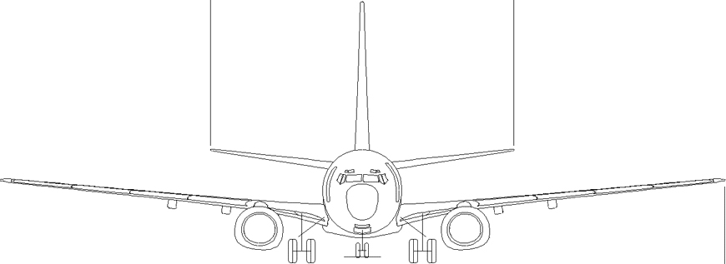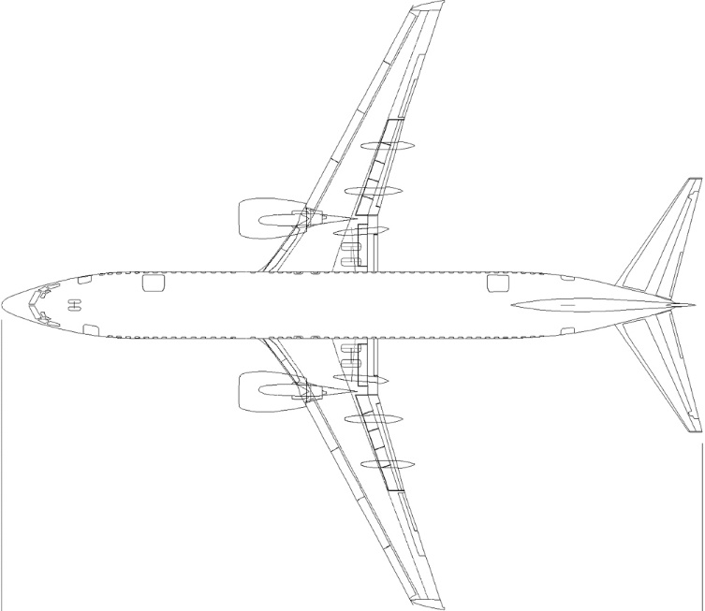

TOP VIEW FRONT VIEW

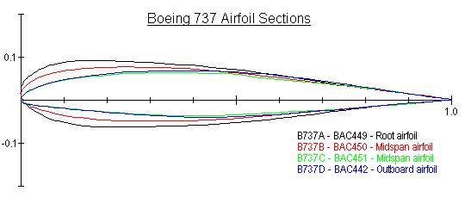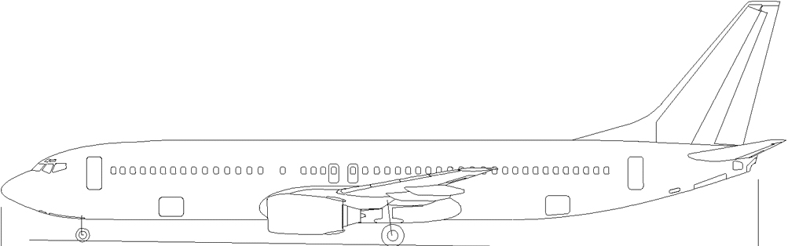 SIDE VIEW

AIR FOIL SECTION

**AEROPLANE DYNAMICS**

* FORCES OF FLIGHT

**WEIGHT**- this is the force that pulls aircraft down due to its mass.

**Lift -** is the force that holds an airplane in the air. The wings create most of the lift used by airplanes.

**THRUST-** this is the horizontal reaction force on the aeroplane due to propellars.

**Drag-** it is the force that acts opposite to the motion of aircraft.It is due to air.An example is putting your hand out of the car and felling it pushed back.

* AXIS OF ROTATION

**Flight dynamics** is the science of [air](https://en.wikipedia.org/wiki/Aircraft) vehicle orientation and control in three dimensions. The three critical flight dynamics parameters are the [angles of rotation](https://en.wikipedia.org/wiki/Angles_of_rotation) in three [dimensions](https://en.wikipedia.org/wiki/Dimensions) about the vehicle's [center of gravity](https://en.wikipedia.org/wiki/Center_of_gravity" \o ") (cg), known as ***pitch*, *roll* and *yaw*.**

**YAW**-The yaw axis has its origin at the center of gravity and is directed towards the bottom of the aircraft, [perpendicular](https://en.wikipedia.org/wiki/Perpendicular) to the wings and to the fuselage reference line. Motion about this axis is called yaw. [Yaw](https://www.grc.nasa.gov/www/k-12/airplane/yaw.html) is the turning of a plane. When the rudder is turned to one side, the airplane moves left or right.

**PITCH**-Thepitch axis (also called transverse axis) has its origin at the center of gravity and is directed to the right, [parallel](https://en.wikipedia.org/wiki/Parallel_(geometry)) to a line drawn from wingtip to wingtip. Motion about this axis is called pitch. [Pitch](https://www.grc.nasa.gov/www/k-12/airplane/pitch.html) makes a plane descend or climb. The pilot adjusts the elevators on the tail to make a plane descend or climb.

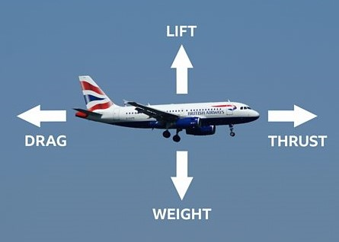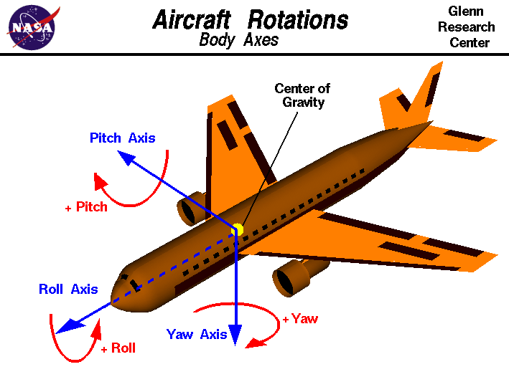**ROLL**-The rollaxis (or longitudinal axis) has its origin at the center of gravity and is directed forward, parallel to the fuselage reference line. Motion about this axis is called roll. Roll is the rolling of a plane left or right

**APPLICATIONS OF AEROPLANE**

* Transportation of people
* Transportation of heavy goods
* Jet planes for military purposes
* For research purposes
* For inspection of areas from high altitude
* Used to reach places of higher altitudes where roads can be constructed.

**KEY AEROPLANE EXPECTATIONS**

* vehicle reliability
* safety
* cost economics
* less noise pollution
* less air pollution
* environment friendly
* lightweight
* easiness to operate

**DESIGN OF ITS COMPONENT**

structural parts include:

* A [*fuselage*](https://en.wikipedia.org/wiki/Fuselage), a long, thin body, usually with tapered or rounded ends to make its shape [aerodynamically](https://en.wikipedia.org/wiki/Aerodynamically) smooth. The fuselage joins the other parts of the airframe and usually contains important things such as the pilot, payload and flight systems.

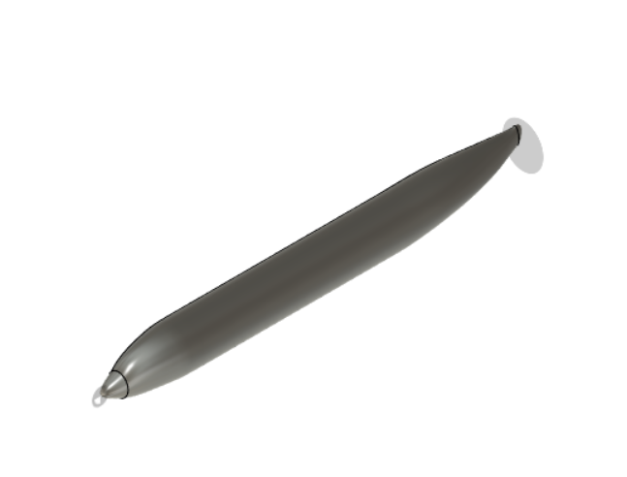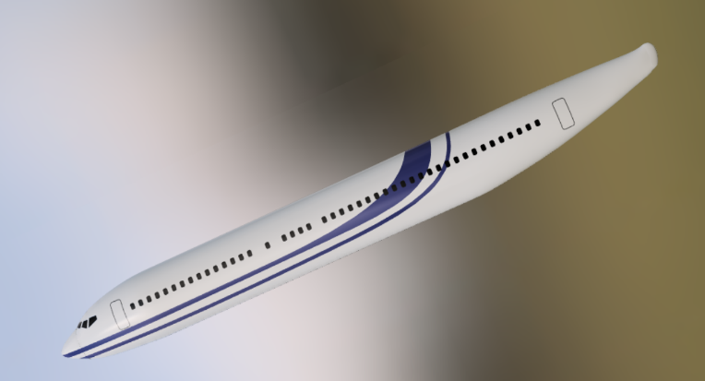

Figure: Model of fueselage

* A [*horizontal stabilizer*](https://en.wikipedia.org/wiki/Horizontal_stabilizer) or [tailplane](https://en.wikipedia.org/wiki/Tailplane), usually mounted at the tail near the vertical stabilizer. The horizontal stabilizer is used to stabilize the plane's [pitch](https://en.wikipedia.org/wiki/Flight_dynamics_(aircraft)) (tilt up or down) and mounts the [elevators](https://en.wikipedia.org/wiki/Elevator_(aircraft)), which provide pitch control.

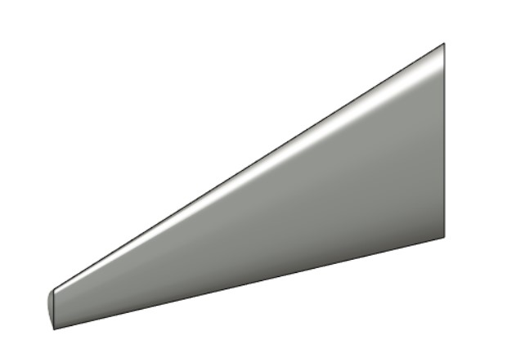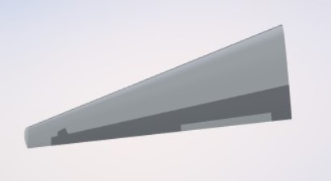

Figure: MODEL OF horizontal stablizer

* A [*vertical stabilizer*](https://en.wikipedia.org/wiki/Vertical_stabilizer) or fin is a vertical wing-like surface mounted at the rear of the plane and typically protruding above it. The fin stabilizes the plane's [yaw](https://en.wikipedia.org/wiki/Flight_dynamics_(aircraft)) (turn left or right) and mounts the [rudder](https://en.wikipedia.org/wiki/Rudder), which controls its rotation along that axis.

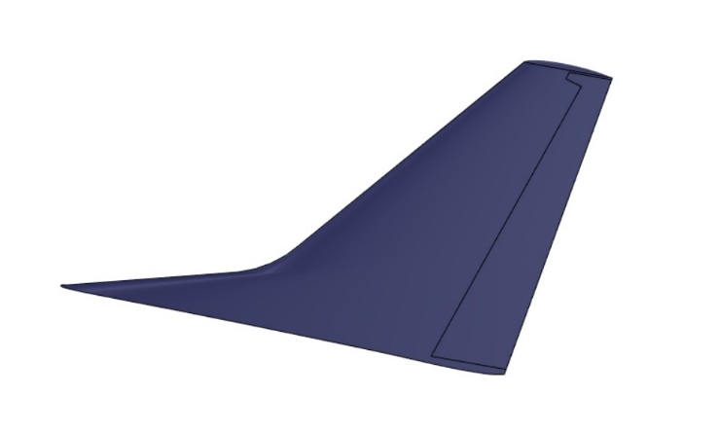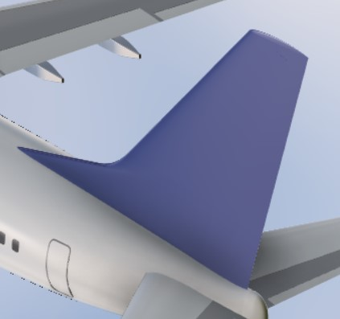

Figure: Model of Vertical Stablizer

* 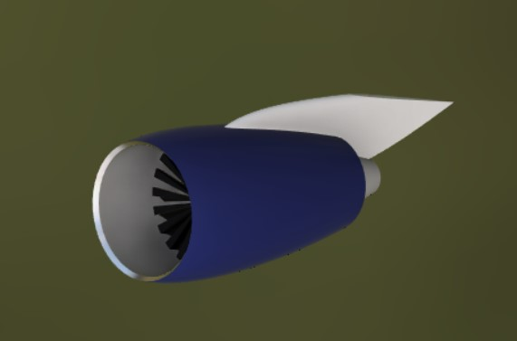The *wings* of a fixed-wing aircraft are static planes extending either side of the aircraft. When the aircraft travels forwards, air flows over the wings, which are shaped to create lift. This shape is called an [airfoil](https://en.wikipedia.org/wiki/Airfoil) and is shaped like a bird's wing. Airplanes have flexible wing surfaces which are stretched across a frame and made rigid by the lift forces exerted by the airflow over them. Larger aircraft have rigid wing surfaces which provide additional strength.

Figure: Model of Wings and Engine 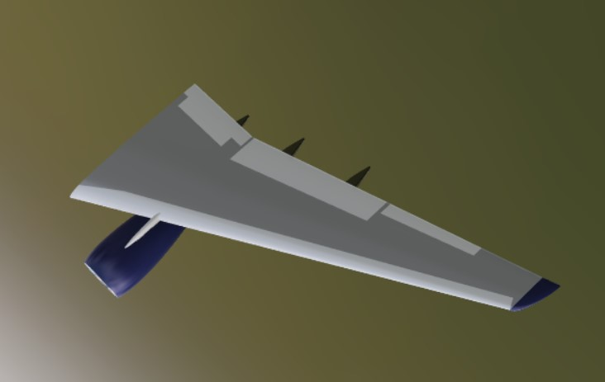

* An *aircraft engine*, often referred to as an aero engine, is the power component of an [aircraft](https://en.wikipedia.org/wiki/Aircraft) [propulsion system](https://en.wikipedia.org/wiki/Air_propulsion). Most aircraft engines are either [piston engines](https://en.wikipedia.org/wiki/Reciprocating_engine) or [gas turbines](https://en.wikipedia.org/wiki/Gas_turbine), although a few have been [rocket](https://en.wikipedia.org/wiki/Rocket_engine) powered and in recent years many small [UAVs](https://en.wikipedia.org/wiki/UAV) have used [electric motors](https://en.wikipedia.org/wiki/Electric_motor).

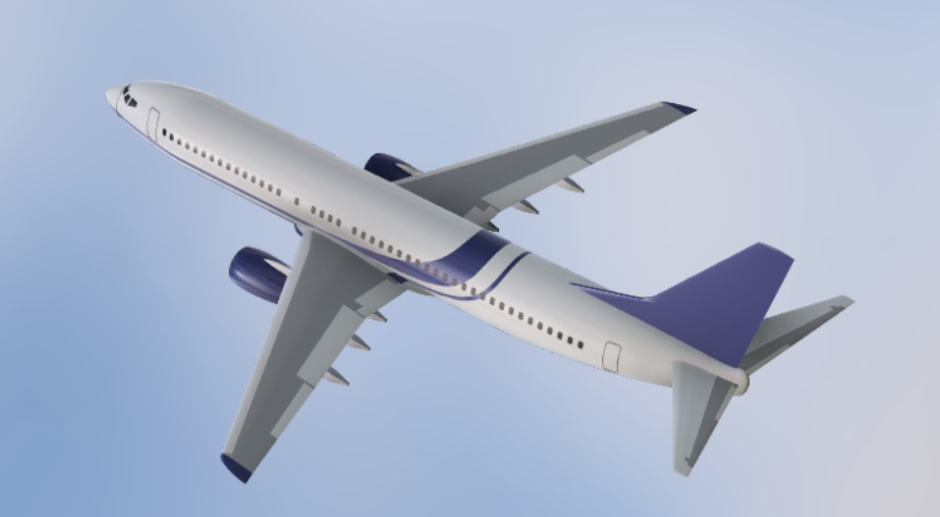  *FINAL MODEL*

**CONCLUSION**

Aeroplane has become one of the important part of our day to day life. It saves huge amount of time which is the current need of present era as in today’s world ,actually, time is money. The above design is used in the manufacturing of Boeing 737 aircraft. The Boeing 737 is a [narrow-body airliner](https://en.wikipedia.org/wiki/Narrow-body_aircraft) produced by [Boeing](https://en.wikipedia.org/wiki/Boeing) at its [Renton Factory](https://en.wikipedia.org/wiki/Boeing_Renton_Factory) in [Washington](https://en.wikipedia.org/wiki/Washington_(state)).

**ACKNOWLEDGEMENT**

I would like to thank our aeroclub for providing us the opportunity . Special thanks to our mentor Mr. Kanak Agrawal for their support and guidance during the whole process. I would also like to thank TEX-Design and Engineering for providing a wonderful you tube tutorial on this project.

***REFERENCES***

* [*https://en.wikipedia.org/wiki/Aircraft_engine*](https://en.wikipedia.org/wiki/Aircraft_engine)
* [*https://en.wikipedia.org/wiki/Aircraft_design_process#Purpose*](https://en.wikipedia.org/wiki/Aircraft_design_process#Purpose)
* Dynamics of flight <https://www.grc.nasa.gov/www/k-12/UEET/StudentSite/dynamicsofflight.html>
* [*https://en.wikipedia.org/wiki/Aircraft_principal_axes*](https://en.wikipedia.org/wiki/Aircraft_principal_axes)
* You Tube series*:* [https://youtu.be/fggnnkmstLQ](https://www.youtube.com/watch?v=fggnnkmstLQ&t=0s)

.